System Design Document
V1.0

Overview
This Gas sensor "grenade" may save lives instead of taking them. The sensor can be thrown into dangerous areas to remotely report levels.

I made this to be a very cheap and easily reproduced product which could simply be thrown into any uncertain environment such as a confined space, building with a possible gas leak, fire etc. Any potential entry person can just toss the ball into the area and remotely receive the gas and smoke levels via voice from several hundred meters away.

I used an MQ2 smoke, LPG (Liquified Petroleum Gas), and CO (Carbon Monoxide) sensor. I used freely available code to get the sensor working with an Arduino Nano. Then taking an Ultra Cheap 433MHZ transmitter to output real voice transmit to any basic radio within the area.

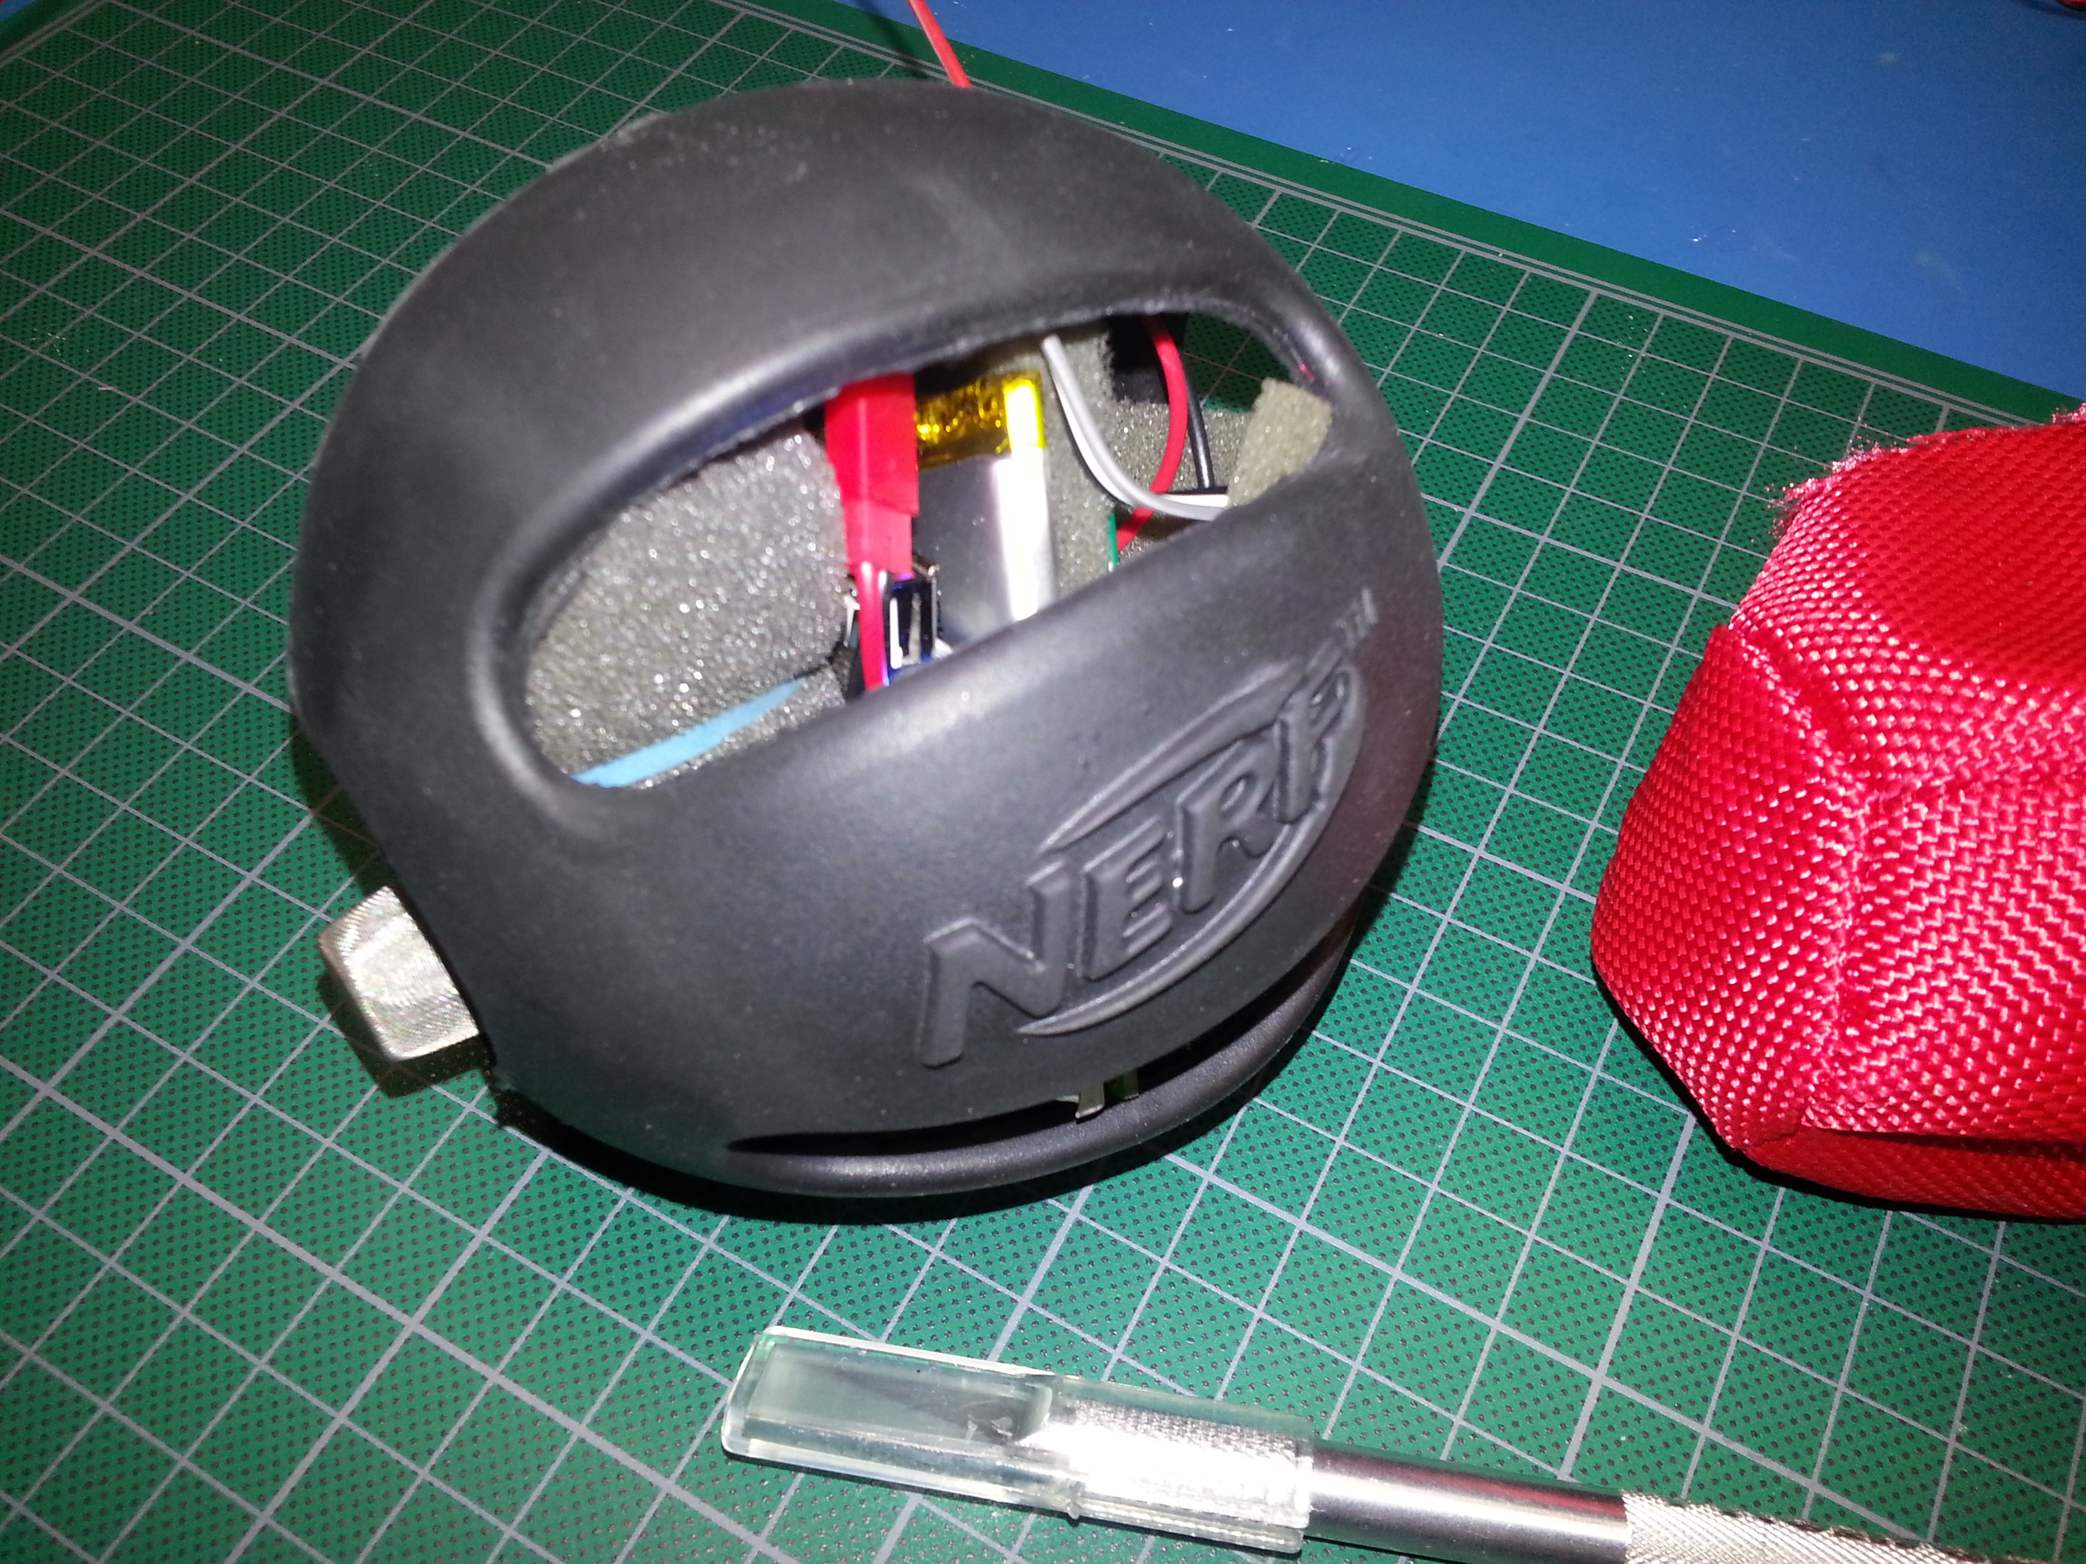

INTRODUCTION

Purpose and Scope
The Gas Sensor takes readings of the potentially dangerous environment and transmits them back to the user in plain voice. The user can remain in a safe area and determine the risk prior to entry into the area.

Project Executive Summary
The project is open to all user modification and improvements. At its core the microcontroller and code provide the sensor data to a basic radio transmitter module. The module then transmits this data in a format any basic radio can receive.

This can be extremely useful for emergency responders and confined space entry to limit personnel exposure to hazardous environments.

System Overview
The Arduino Nano micro controller is utilized by uploading the provided code (requires the supporting library). The micro controller monitors gas sensor and takes this data, transforms it to a human voice output and sends it to the transmitter.

Full Overview Video:
https://www.youtube.com/watch?v=_83s2re38ZU

Design Constraints
Very little restraints exist. In fact- there are many I/O pins unused and are available for future integration. Some custom timing is used via the “Talkie” library so this needs to be considered if people adapt further hardware/functions.

Talkie Library Used License: Attribution-NonCommercial-ShareAlike 3.0 Unported (CC BY-NC-SA 3.0) Sandbox Electronics

Future Contingencies
NA at this time

Document Organization
NA

Points of Contact
Support provided via the forum at http://mkme.org as well as the GIT repository.
https://github.com/MKme/Gas-Sensor-Grenade

Support for the libraries used to support the code is provided by the original authors only. Restrictions for use can be found on their respective support pages (linked within the Arduino Source Code)

Forum Thread:
http://mkme.org/forum/viewtopic.php?f=27&t=680

Project References
Initial design completed spring 2015. Testing and updates completed through summer 2015 at which point the project was fully released via Hackaday website:

https://hackaday.io/project/4742-gas-sensor-for-emergency-workers

Glossary
Arduino- Arduino is an open-source computer hardware and software company, project and user community that designs and manufactures microcontroller-based kits for building digital devices and interactive objects that can sense and control the physical world.

The project is based on a family of microcontroller board designs manufactured primarily by SmartProjects in Italy, and also by several other vendors, using various 8-bit Atmel AVR microcontrollers or 32-bit Atmel ARM processors. These systems provide sets of digital and analog I/O pins that can be interfaced to various expansion boards ("shields") and other circuits. The boards feature serial communications interfaces, including USB on some models, for loading programs from personal computers. For programming the microcontrollers, the Arduino platform provides an integrated development environment (IDE) based on the Processing project, which includes support for C,C++ and Java programming languages.

MQ2- Gas sensor module used for reading the levels

ASK- Amplitude shift keying

TX- Transmit

LPG- Liquefied Petroleum Gas

CO - Carbon Monoxide

SYSTEM ARCHITECTURE
Arduino Nano (Atmel) provides overall control, reading from the sensor and transmitting via the ASK TX module.

System Hardware Architecture
- Arduino Nano- The Arduino Nano is a small, complete, and breadboard-friendly board based on the ATmega328 (Arduino Nano 3.x) or ATmega168 (Arduino Nano 2.x). It has more or less the same functionality of the Arduino Duemilanove, but in a different package. It lacks only a DC power jack, and works with a Mini-B USB cable instead of a standard one. The Nano was designed and is being produced by Gravitech

- MQ2 Gas Senor- Provides readings for smoke, LPG and CO.

- 433 MHZ Transmitter- Transmits voice signal

- Power Boost 500- Charger/Boost converter provided by Adafruit

- 1S LiPo- 1 cell lithium polymer battery for supply

- Enclosure- Soft/rubber enclosure provides protection for the electronics

System Software Architecture
- loop()- All code execution

- Calibration- Calibration required for MQ2 Sensor and executes automatically

- Talkie Voice- Talkie library used to synthesize human voice

Full code explanation and overview video here:
https://www.youtube.com/watch?v=THKldqk9lY8

Internal Communications Architecture
Direct connection from MQ2 to Arduino and output via TX module

FILE AND DATABASE DESIGN
All files and updates via GitHub:

https://github.com/MKme/Gas-Sensor-Grenade

Database Management System Files
- NA

Non-Database Management System Files
- NA

HUMAN-MACHINE INTERFACE
- External radio receiver is required. Any FM receiver capable of the 433MHZ band will work. Although the transmission is sent via ASK (AM) the FM receivers are able to output this very clearly and reliably.

Inputs
- MQ2 Gas Sensor via MQ_PIN

Outputs
- Voice output to TX via Pin 3

DETAILED DESIGN
NA

Hardware Detailed Design
- NA

Software Detailed Design
- NA

Internal Communications Detailed Design
- NA

EXTERNAL INTERFACES
NA

Interface Architecture
NA

Interface Detailed Design
NA

SYSTEM INTEGRITY CONTROLS
NA

